Lab: Stacks Manual

About
For this lab, you will build a manual for yourself that you can refer to in the future for all the information you need to build a stack. The idea is that if you understand how the functionality works you won’t have to memorize the code; you can derive that code from any time, in any language.
For each function, you should describe how it works (in English or pseudocode), sketch a representation of what occurs, and copy the Linked List code that we work on during class. With each of these, you will have a “manual” to refer back to any time.

Core functions

void Push( const T& data )
Steps | Array stack-  If there is nothing in the m_array then allocate memory to that array.  If the m_arraysize is equal to the itemcount, then allocate memory for a temporary array, then iterate through the m_array and put the m_array items into the temporary array. Then delete the m_array. Then set the m_array to the temporary array.  Then put the newData into the m_array. Then increment the item count.  Linked list stack-  First you are going to allocate memory for the list  Then if ptrLast is equal to nullptr (so the list is empty), you are going to set the ptrfirst and ptrlast to the data that you want into the list.  If the list has at least one item, then you will point the ptrLasts ptrNext to the new node.  Then lastly increment the itemcount.
Drawing | 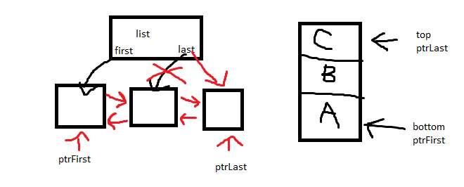
Array implementation | template <typename T>  void Push(const T& newData) {  if (m_array == nullptr) {  //allocate memory to the array  m_array = new T[size];  m_arraySize = size;  }  else if (m_itemCount == m_arraySize) {  T * tempArray = new T[m_arraySize + 10];  for (int i = 0; i < m_itemCount; i++) {  tempArray[i] = m_array[i];  }  delete [] m_array;  m_array = tempArray;  m_arraySize = m_arraySize + 10;  }  m_array[m_itemCount] = newData;  m_itemCount++;  }
Linked implementation | template <typename T>  void List<T>::PushBack(const T& newData) noexcept  {  // Allocating memory  Node<T>* newNode = new Node<T>;  newNode->data = newData;  // Place the node in the list:  // List is empty  if (m_ptrLast == nullptr)  {  // Point the first & last ptrs to the new node  m_ptrFirst = newNode;  m_ptrLast = newNode;  }  // List has at least one item  else  {  // Point the last node's ptrNext to the new node  m_ptrLast->ptrNext = newNode;  newNode->ptrPrev = m_ptrLast;  m_ptrLast = newNode;  }  // Increment item count:  m_itemCount++;  }

void Pop()
Steps | Array stack-  If the itemcount is greater than 0 (so that there is at least something in the array) then use lazy deletion to decrement the itemcount  Linked list stack-  If the list is empty, do nothing  If the ptrfirst is the same thing as ptrlast (so that there is only one item in the list)then delete ptrfirst and set ptrfirst and ptrlast to nullptr  If there is more than one item in the list then find the second to last item, then delete the last item, then set the second to last item as the last item, then set the last items ptrnext to nullptr
Drawing | 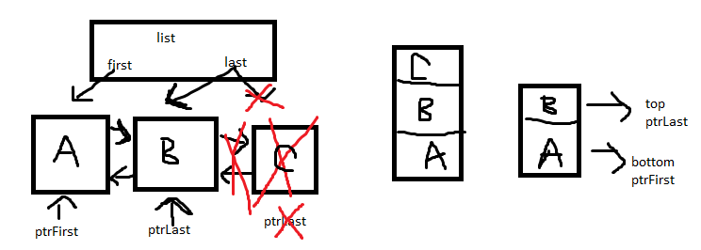
Array implementation | void Pop() {  if (m_itemCount > 0) {  m_itemCount--; //lazy deletion  }  }
Linked implementation | template <typename T>  void List<T>::PopBack() noexcept  {  if (m_ptrFirst == nullptr)  {  // List is empty; ignore  return;  }  // there is only one item in the list  else if (m_ptrFirst == m_ptrLast)  {  delete m_ptrFirst;  m_ptrFirst = nullptr;  m_ptrLast = nullptr;  }  // there is more than one item in the list  else  {  // Locate the second-to-last item  Node<T>* ptrSecondToLast = m_ptrLast->ptrPrev;  // Free the memory for the last item  delete m_ptrLast;  // Set the new last item  m_ptrLast = ptrSecondToLast;  // Set the last item's ptrNext to nullptr  m_ptrLast->ptrNext = nullptr;  }  m_itemCount--;  }

T& Top()
Steps | Array stack-  Check if the array is equal to nullptr or the itemcount is equal to 0, if so throw an exception error that the array is empty.  If the array has some item in it, then return the arrays value at the itemcount – 1 (which returns the top most item in the stack)  Linked list stack-  For this one you are going to get the item at the back of the linked list  To do so first check if the ptrLast is equal to nullptr, and if it is then throw an exception error that you cannot get the top of the stack because the list is empty.  If the list is not empty/has at least one item in the list, then return the data that’s in ptrLast (which is the top most data in the stack)
Drawing | 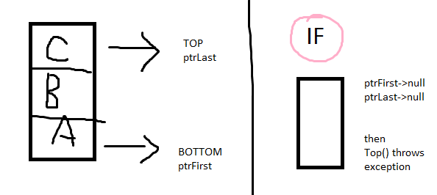
Array implementation | T& Top() {  If (m_array == nullptr || m_itemCount == 0) {  throw runtime_error(“The array is empty”);  }  return m_array[m_itemCount - 1];  }
Linked implementation | template <typename T>  T& List<T>::GetBack()  {  if (m_ptrLast == nullptr)  {  throw out_of_range("Can't GetBack() for empty list!");  }  return m_ptrLast->data;  }

